

2024 Annual Conference – November 1, 2024
Hamline University

Sundin Music Hall

8:30-9:00am: Registration/Coffee

9:00-9:15am: Welcome/introductions
Dr. Lacey Chu, St. Catherine University

9:15-10:15am: Walter Heller Lecture

Dr. Mariacristina De Nardi, Thomas Sargent Professor of Economics, University of Minnesota.

“Health inequality and economic disparities by race, ethnicity, and gender.”

10:15-10:30 am: Coffee break

10:30-11:45 am: Panel discussion on economic disparities in Minnesota:
Elizabeth Engle, Matthew Gregg, Allison Liuzzi, and Kristine West

Kay Frederick’s Room – Klas Center

Noon – 1:00 pm: Lunch, MEA Business Meeting, Student Paper Contest winners

1:00-2:00 pm: Student Research Posters – mingle and network!

Biographies of our speakers

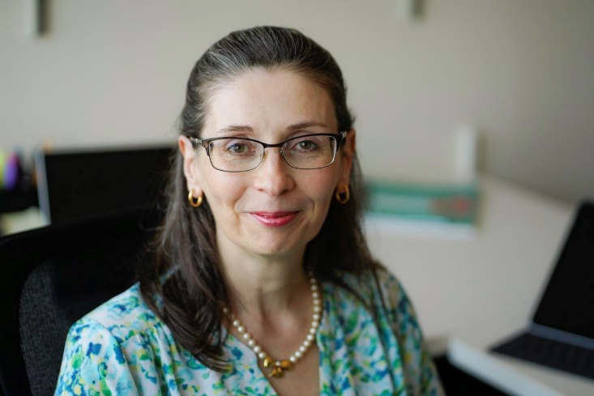 | Dr. Mariacristina De Nardi  Walter Heller Lecture  Mariacristina De Nardi is the Thomas Sargent Professor at the University of Minnesota, a Consultant for the Opportunity and Inclusive Growth Institute at the Federal Reserve Bank of Minneapolis; and a Faculty Research Fellow of the CEPR and NBER. Her research focuses on savings, wealth inequality, Social Security, health, medical expenses, entrepreneurship, wage and earnings dynamics, and taxation. De Nardi's research has been published in the Review of Economic Studies, the Journal of Political Economy, the American Economic Review, the Journal of Monetary Economics, the Journal of the Economic European Association, and the Review of Economic Dynamics. Before joining the University of Minnesota in 2019, De Nardi was a senior scholar at the Opportunity and Inclusive Growth Institute at the Federal Reserve Bank of Minneapolis, a professor at UCL, a Senior Economist at the Federal Reserve Bank of Chicago, and an Assistant Professor at the University of Minnesota. De Nardi received a B.A. from the University of Venice in Italy and a Ph.D in Economics from the University of Chicago.

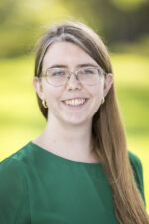 | Elizabeth Engle  Elizabeth Engle is an Assistant Professor of Economics at Macalester College whose research focuses on low-wage labor markets. She studies programs and policies that aim to improve conditions for workers or remove barriers to accessing occupations with more opportunity for economic advancement. Her past work has examined issues like criminal-record-based restrictions on occupational licenses and the extension of minimum wage, overtime, and travel pay protections to home care workers. She is a faculty affiliate of the Wilson Sheehan Lab for Economic Opportunities (LEO) at the University of Notre Dame.
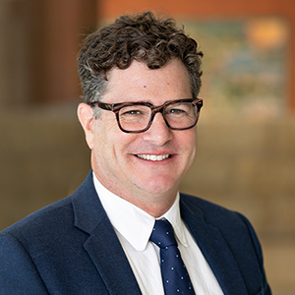 | Matthew Gregg  Matthew is a senior economist in Community Development and Engagement, where he focuses on research for the Center for Indian Country Development. Before joining the Bank, Matthew was an associate professor of economics at Roger Williams University and, prior to that, a visiting economics professor at Grinnell College. He has conducted research on a wide range of topics within tribal economic development and published work on historical development, Indian removal, land rights, and agricultural productivity. Matthew is a member of the Association for Economic Research of Indigenous People.  Matthew received his Ph.D. from the University of Georgia, where he specialized in applied microeconomics and economic history.
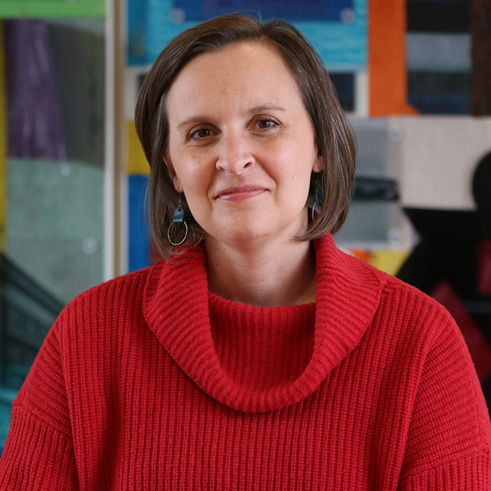 | Allison Liuzzi  As Project Director of Minnesota Compass, Allison works with a team of researchers to describe and measure progress on topics related to our shared quality of life in Minnesota. She has particular interest in demographic trends, employment and workforce development, and immigration. Allison previously served as president of the Community Indicators Consortium, an international organization that supported communities’ efforts to use data to improve quality of life.  Allison joined Wilder Research in the spring of 2012. She earned her bachelor’s degree from Luther College, her master's degree from Michigan State University, and completed her doctoral coursework in sociology at the University of New Hampshire.  Allison lives with her spouse and elementary-aged child in Saint Paul’s Como Park neighborhood. Outside of the office, she’s likely to be playing board games with her family, walking one of her rescue pups, or lifting weights at the gym.

