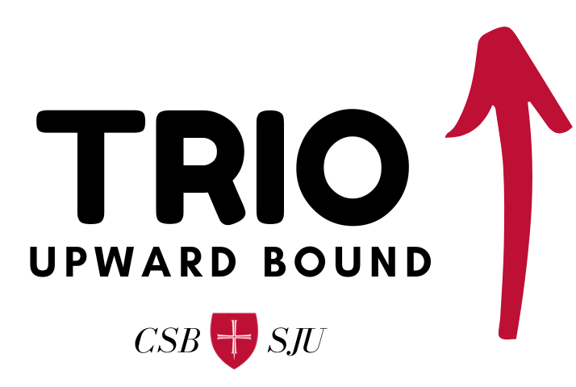

Application to Join

Upward Bound is all about discovering and reaching college dreams. There are Upward Bound programs offered at various high schools and colleges throughout the country, and over 60 years, they have collectively helped two million students enroll and graduate from college. Upward Bound is one of many TRIO programs, all of which are funded by the US Department of Education under Title IV of the Higher Education Act of 1965. This means high school students don’t pay for our services!
Earning a college degree unlocks so much for the average person, allowing for more lifetime income, more fulfilling careers, and all the benefits that come with financial security. Historic, systemic, and current barriers to higher education are multiple and complex. Studies have shown that while financial insecurity is one of the main reasons people don’t earn a college degree, there are other barriers Upward Bound programs can help address, including social, cultural, class, and mental health barriers.
Our Upward Bound program is hosted by the College of Saint Benedict and Saint John’s University (sometimes referred to as “CSB & SJU”) in St. Joseph, MN. We are operated by a Program Director and two Program Advisors. We support four high schools in central Minnesota: Tech, Apollo, Sauk Rapids-Rice, and Willmar. Our program has been active for more than 25 years!
To achieve our mission of supporting high school students succeed in their college dreams, Upward Bound is most effective when a student joins us while entering high school and stays with us through graduation. Students can join anytime in high school, however, and take part in our Academic Year offerings which are focused on academic readiness, and our Summer Program offering, focused on financial literacy, social and emotional learning, and cultural experiences.
As with all complex problems, the solution to accessing higher education needs to be holistic and well-rounded. This includes family involvement, student engagement and participation, and a commitment to one’s own self and their goals. Students in our program work with their Program Advisor to navigate and make the most of these components, and always have access to the Program Director if more support is needed.
By filling out this application to join Upward Bound, you (the student) are committing yourself to your dream of attending college, and we are committing ourselves to doing what it takes to help you succeed! You’ll need the help of your parents/guardians to fill in some parts of the application.
Program Contact Information

Upward Bound
College of Saint Benedict
Henrita Academic Building
37 South College Avenue
St. Joseph, MN 56374

Alexandra Scheibelhut
Program Director
Office: 320-363-5887
Cell: 651-666-9813
Email: AScheibel001@csbsju.edu
Contact person for all parents, and available to students as needed

Shelley Gemza
Program Advisor
Office: 320-363-5351
Cell: 612-419-1479
Email: SGemza@csbsju.edu
Contact person for parents and students at Apollo and Willmar High Schools

Dillon Meade
Program Advisor
Office: 320-363-5268
Cell: 319-651-4006
Email: DMeade001@csbsju.edu
Contact person for parents and students at Tech and Sauk Rapids-Rice High Schools

Social Media
General Email: ubcsbsju@gmail.com
Website: www.csbsju.edu/upward-bound
Facebook: www.facebook.com/profile.php?id=100081779087127
YouTube: www.youtube.com/@csbsjuupwardbound1673
Instagram: www.instagram.com/csbsjuub

Program Application: Student Information

Student Name:
 |  | First |  | Middle |  |  | Last
Address:
 |  | Street |  | City |  |  | State | Zip
Cell Phone: |  |  |  | Home Phone |  | (optional)
Email: |  |  |  |  | T-Shirt Size:
Date of Birth: |  |  |  | Age: |  |  | Male or Female
School: |  | Tech | Apollo | SRR |  | Willmar
Grade: |  | Rising 9th | Freshman | Sophomore |  | Junior | Senior
Citizenship: |  | US Citizen |  | Permanent Resident |  |  | US National
SSN: _____________________

Race: | Black or African American | American Indian or Alaskan Native | Native Hawaiian or other Pacific Islander | Asian | Hispanic | White

Which language(s) do you speak?
What is your school gradebook username?
What is the password?
Do you have an IEP? |  | Who is your case worker?

Students must be a US Citizen, National or Permanent Resident to qualify for Upward Bound (HEOA 645.3). Admission into the Upward Bound program at CSB & SJU is open to those who meet the eligibility criteria, regardless of gender, race, national origin, color, age, religion, or disability. No person shall be subjected to any discrimination prohibited by the Civil Rights Act of 1964 as amended, Section 504 of the Rehabilitation Act of 1972, the Americans with Disabilities Act, and any other applicable laws.
Program Application: Family Information

Parent/Guardian #1
Name:
 |  | First |  | Last
Address:
(or write “same”) |  | Street |  | City |  |  |  |  | State | Zip
Cell Phone:
Email: |  |  |  |  |  |  | Relationship:

Parent/Guardian #2
Name:
 |  | First |  | Last
Address:
(or write “same”) |  | Street |  | City |  |  |  |  | State | Zip
Cell Phone:
Email: |  |  |  |  |  |  | Relationship:

Who does the student currently live with? Circle all that apply:
Biological Parent | Step-Parent | Adoptive Parent | Foster Parent
Relative other than parent (please specify)
Guardian, not a relative (please specify)

Who are the student’s legal guardians? Circle all that apply:
Both biological parents |  | Biological mother only | Biological father only | Ward of the court
Other (please specify)

Do you request documents to be provided in another language, or for us to provide interpreter services? If yes, which language? ________________________________
2
Program Application: Family Information

Please list everyone who lives in the same household as the student:
Name | Age | Relationship to Student

What is the highest grade level completed by the student’s biological father? Circle one.
Unknown Elementary High School 2-year degree (AA/AS) 4-year degree (BA/BS)

What is the highest grade level completed by the student’s biological mother? Circle one.
Unknown Elementary High School 2-year degree (AA/AS) 4-year degree (BA/BS)

What was the household’s total taxable income last year? ______________________________
Note: This amount can be found on Line 15 of your Form 1040 of your tax return. The amount will be less than your “gross income”. If you did not file taxes last year, please write last year’s estimated annual household income, and check this box to certify its accuracy.
Parent/Guardian Signature: _________________________________________ Date: _____________
3
Program Application: Release of Records

The personal information provided in this Upward Bound application is sent to the federal government, specifically the Department of Education. Your information is protected by the Family Educational Rights and Privacy Act. Nobody may see the information unless they work with Upward Bound or are specifically authorized to do so. We must collect personal information to determine eligibility for participation in the program, and this information helps Upward Bound and the Department of Education measure the outcomes of the program.

For the duration my child is enrolled with Upward Bound, and for six years after they graduate high school, I authorize the release of all following information to the Upward Bound program at the College of Saint Benedict & Saint John’s University:
- Transcripts and report cards from the student’s high school
- Standardized test scores, including ACT results
- School attendance records
- FAFSA application and Financial Aid award letters
- WIOA, TANF, and Social Security verification
- Free/reduced lunch verification
- National Student Clearinghouse database information

Student Name
Student Signature |  |  |  |  |  | Date:
Parent/Guardian Name
Parent/Guardian Signature |  |  |  |  |  | Date:

4

