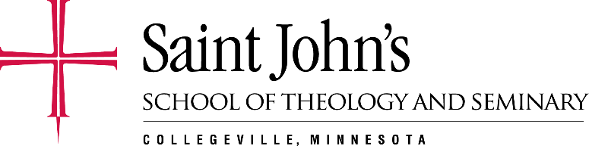
June 27, 2017

Greetings,

On behalf of the faculty, staff, and students of School of Theology and Seminary here at Saint John’s, welcome to Collegeville! We happy to be hosting you for the 32nd annual Monastic Institute.

This year we are so grateful to our speakers, Monsignor Kevin Irwin, Sr. Michelle L’Allier, OSF, Dr. Bernie Evans, Sr. Anne McCarthy, OSB, and Abbot John Klassen, OSB, respectively. We are excited to reflect on Pope Francis’ encyclical: Laudato Si’ in response to today’s challenges on environment sustainability. I know that the wisdom that the speakers impart through the next four days will be inspiring and keep us reflecting on our own individual journeys and our sacred calling to caring for our common home.

We are also thankful for the hospitality and gracious invitation to spend Wednesday evening with the Sisters at St. Benedict’s Monastery in St. Joseph and share in Eucharist, dinner, and evening prayer. We will provide transportation.

Included in this registration packet you will find a schedule of events, a campus map, directions on how to connect to the campus internet, and information about our speakers. Also included is information from the School of Theology and Seminary, The Liturgical Press, the Abbey Gift Shop and Market, and more. We encourage you to stop by these places while you are on campus. They can be located using your campus map, or by asking one of our staff members.

In addition, the Arboretum offers beautiful wilderness trails that you are free to explore. Many visitors on campus enjoy a walk out by Lake Sagatagan to the Stella Maris Chapel. We have trail maps if you wish to join us for Prayerful Trail Walk starting at 3:30pm on July 2nd and on July 6th. It is a great way to explore the beautiful nature while praying together at the same time. We will have two options for social activity on July 5th: seeing Saint John’s Bible-heritage edition and visiting the pottery studio. If you wish to go to either one of these places, please do let me know. The Hill Museum and Manuscript Library (HMML) has been recently renovated and their reading room will be open Monday-Friday (except Tuesday, July 4th) from 8:00am – 4:30pm.

If you need anything throughout the week while you are with us, please let us know and we are happy to assist you.

Peace,

Janice Kristanti
Monastic Institute Assistant Program Coordinator
Saint John’s School of Theology and Seminary

