Monastic Institute 2017 Speaker Profiles

Dr. Bernie Evans
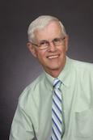
Bernard Evans recently retired from the faculty at Saint John’s School of Theology and Seminary where he served as Associate Dean for Faculty and occupied the Virgil Michel Ecumenical Chair in Rural Social Ministries. Evans taught courses on Christian social ethics, environmental theology, and ministry in rural communities. His most recent publications include the books Lazarus at the Table: Catholics and Social Justice (2006), Vote Catholic? Beyond the Political Din (2008), and Stewardship: Living a Biblical Call (2014), all published by the Liturgical Press.

