Monastic Institute 2017
Speaker Profiles
S. Anne McCarthy, OSB
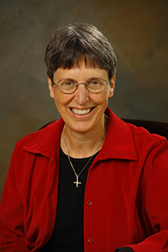
Anne McCarthy, OSB, coordinates Erie Benedictines for Peace and is on staff with Benetvision (www.joanchittister.org) and Monasteries of the Heart (www.monasteriesoftheheart.org). At Monasteries of the Heart, she coordinates the online Monasteries of the Heart communities, facilitates the Listening Hearts program—a spirituality program for women in Erie, and is the resource person for Monasteries of the Heart in prisons. She leads retreats on nonviolence and feminist spirituality and holds an MA in Theology from St. John’s University, Collegeville in monastic studies. Long involved in peace and justice ministry nationally and locally, Anne is president of the board of the international Monastic Interreligious Dialogue (DIM-MID).

