Monastic Institute 2017
Speaker Profiles

Abbot John Klassen, OSB
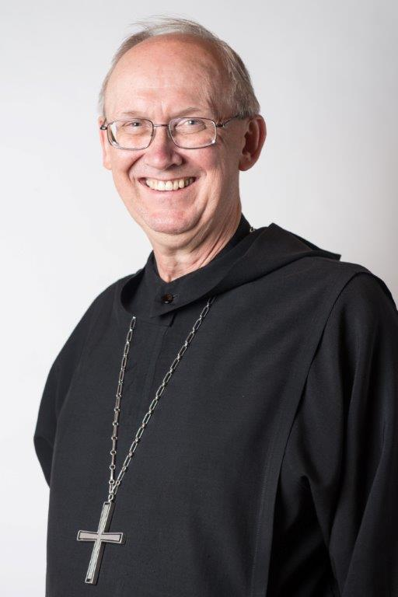
Abbot John Klassen, OSB is in his seventeenth year as leader of Saint John’s Abbey in Collegeville. He leads a community of 120 Benedictine monks who sponsor and work at Saint John’s University, Saint John’s Preparatory School, the Liturgical Press as well as in parishes, hospitals and retirement centers, mostly in Minnesota. With a degree in bio-organic chemistry from Catholic University of America in 1985, he taught organic and biochemistry, as well as an ethics course on technology at Saint John’s University from 1983-2000 before being elected abbot. He particularly enjoys studying the Rule of Benedict and other monastic sources and relating monastic themes to the challenge of contemporary living.

