Fields and vineyards, rocks and woods, and all the beauties of the field,
flowing springs and blooming gardens, earth and fire, air and wind:
all these he urged to love of God and to willing service.
Finally, he used to call all creatures by the name of "brother" and "sister"
and in a wonderful way, unknown to others,
he could discern the secrets of the heart of creatures
like someone who has already passed
into the freedom of the glory of the children of God….

His highest aim, foremost desire, and greatest proposal was,
to pay heed to the holy gospel in all things and through all things,
to follow the teaching of our Lord Jesus Christ
and to retrace His footsteps completely with all vigilance and all zeal,
all the desire of his soul and all the fervor of his heart.
-The Life of St. Francis by Thomas of Celano, 81, 84

* * * * * * * * * * * * * * * * * * * * * *

In art he [Francis] praises the Artist; whatever he discovers in
creatures he guides to the Creator. He rejoices in all the works of the
Lord’s hands, and through their delightful display he gazes on their life-
giving reason and cause. In beautiful things he discerns Beauty Itself...
-2 Celano 124

* * * * * * * * * * * * * * * * * * * * * *

Different Meanings of Poverty; see Robert McAfee Brown’s Gustavo Gutierrez:
An Introduction to Liberation Theology.

I. Material or Abject Poverty
– Lack of economic resources for humane life;
– People in a subhuman condition; it is always to be opposed

II. Spiritual Poverty
–An interior attitude of non-attachment to the goods of this world;
–Also refers to the inner poverty of our brokenness and our suffering.

III. Evangelical Poverty – biblical understanding…are two:
- a scandalous condition against human dignity/God’s will (Jesus, prophets,
Jewish tradition);
- an attitude of openness to God, a spiritual childhood, attitude opposed to pride or self-sufficiency, ie: faith/trust in the Lord; ie: the poor are blessed (cuz the Kingdom coming will put an end to their poverty by creating a world of fellowship;
- The above two come together in third understanding of a true biblical understanding: poverty as a commitment of solidarity and protest.

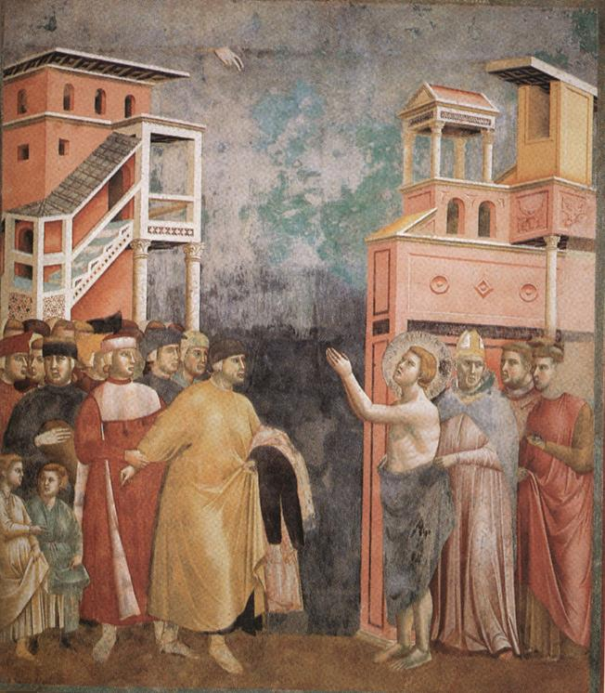
Unlike the common spirituality of his time, Francis did not separate the spiritual world from the material world, and he certainly did not devalue the material world as godless. He viewed the world, the earth, and everything in nature as God’s creation and a place of incarnation – the presence of God….Francis did not see human beings as above or outside of the rest of nature. He saw them as co-creatures of God, as sisters and brothers of all creatures. He expressed his spirituality uniquely and poetically in the Canticle of the Creatures (see http:/www.appleseeds.org/canticle.htm) at the end of his life. The canticle does not praise God for creation. Francis did not stand next to nature to thank God for nature. Rather, he stood in line with the community of creatures and – as part of that community – praised God as the source of all life and of all creation. The creatures’ praise of God consists in their being what they are – that they become what they were created to be.

….St. Paul said that the community of Christians forms the body of Christ, that the joys and sufferings of each individual member contribute to the well-being and suffering of the entire body (cf. 1 Cor 12:12-31; Col 1:18; 2:18-20; Eph. 1:22-23; 3:19; 4:13). For Francis, the same truth applies to the entire cosmos. Today we can see the confirmation of the truth of his insight in scientific reports. Destruction in one part of the world is leading to suffering in the entire world.

- Accessed 9-23-16: http://francis35.org/pdf/ecology_booklet_III.en.pdf, 2014.

* * * * * * * * * * * * * * * * * * * * * *

Ilia Delio, The Humility of God: A Franciscan Perspective, Cincinnati, OH:
St. Anthony Messenger Press, 2005:
Bonaventure describes the humility of God through the words of John’s Gospel ‘the Word was made flesh (John 1:14). He writes:
These words give expression to that heavenly mystery and that admirable
sacrament, that magnificent work of infinite kindness, which consists in the fact
that the eternal God has humbly bent down and lifted the dust of our nature into
unity with His own person. (Sermon II on the Nativity of the Lord, Bonaventure)

In the Incarnation, Bonaventure says, God bends down to embrace us in Love. (p.4)

Well, if God bends over in love for us in and through the Word incarnate, then we who are little “words” must bend over in love for one another and all creation if the universe is to find its fulfillment in Christ. (p.6 )

* * * * * * * * * * * * * * * * * * * * * *

All citations of writings by/about Saint Francis of Assisi:
Regis J. Armstrong, J. A. Wayne Hellman, and William J. Short. Francis of Assisi:
Early Documents: The Saint. Vol. 1. New York: New City Press, 1999.

