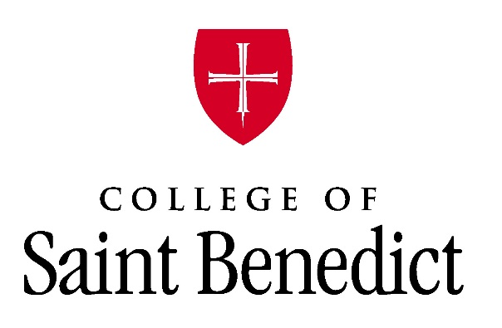
Snowbird Summer Housing

Accommodations are available beginning May 28 2024 and ending August 1, 2024. A 30-night minimum stay is required and payment is due upon check-in. Apartments have two or four bedrooms, kitchen, living room, bathroom(s) and washer/dryer access. Enjoy the relaxing environment of St. Joseph while still being close to St. Cloud and only one hour from the Twin Cities!
Rate Information for 2 Guests, Ages 50 and Older
2 Bedroom Monthly Stay: $1,050.00
4 Bedroom Monthly Stay: $1,150.00
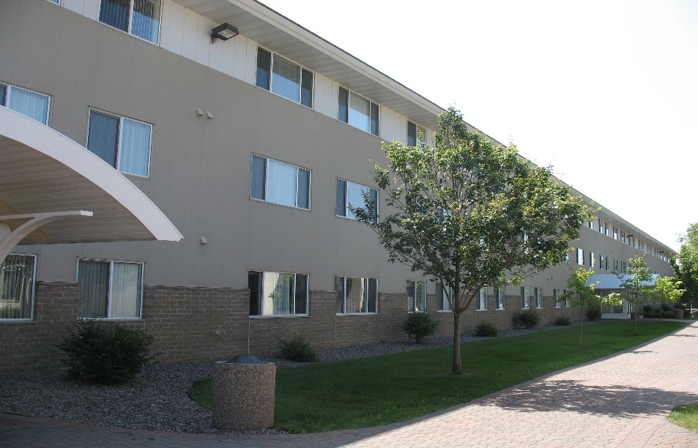

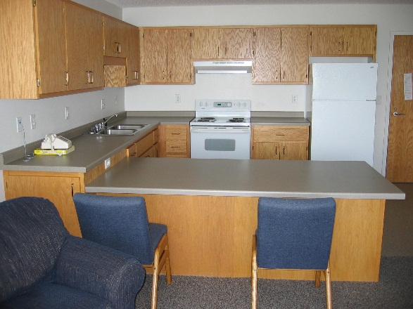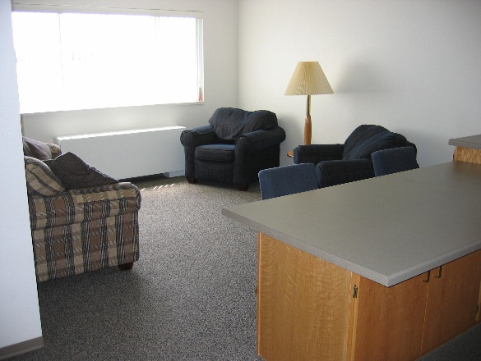

Expectations and Room Amenities

Each apartment offers:
Bedroom
- Bed (standard twin size)
- Wardrobe with drawers and hanging space
- Desk and Chair
- Linens: Each room is supplied with bed linens, pillow, bath towels, wash cloths, and hand towels
Living Room
- Couch
- Chairs
- Table
Kitchen
- Counter with stools
- Full size refrigerator
- Oven/Stove
- Garbage cans and recycling bins
Each apartment is air-conditioned. They are also equipped with a vacuum, washer and dryer.
Complimentary Wi-Fi Internet Service
Apartments do not have televisions or cable access. Guests need to provide their own television with streaming services. No telephone access.
Things to Bring
- Kitchen Supplies: Dishes, utensils, microwave (if desired), coffee maker, can opener, etc.
- Television
- Clothes Hangers
- Clock/Radio

Utilities
All utilities are included with the monthly rental fee.

General Information
Apartments are smoke-free and pet free.

Recreational Facilities

- Tennis Courts
- Full access to our campus fitness center is available with your stay

- Walking Paths
- Close access to the Wobegon Trail

For Reservations contact:
Erika Boike
(320) 363-5791 or, eboike001@csbsju.edu.

