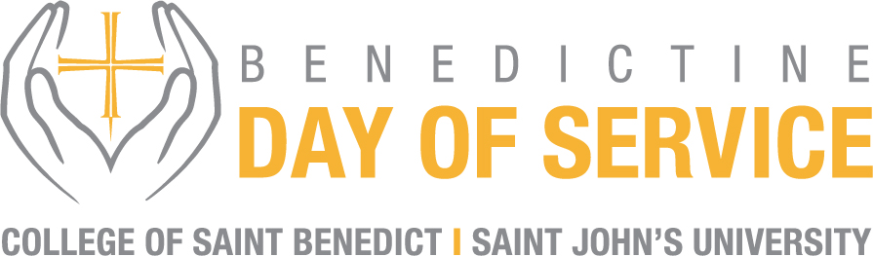

**April 12, 2025**

**“NEIGHBORS HELPING NEIGHBORS”**

**This year’s day of service will continue to focus on helping those struggling with life’s basic needs. What needs does your community wish were fulfilled?**

**Possible Project Ideas:**

* **Food Insecurity** – Although we have significantly impacted many communities with our day of service events during the last several years, food insecurity remains a major issue in many areas of the country.
* **Clothing** – One of our basic needs, clothing protects us from a range of weather conditions. What might a clothing drive look like in your community? What are some of the most in demand clothing items that your local non-profits and shelters could benefit from?
* **Water** – If your region is located in a place with severe heat during the summer months, might there be a need for a water drive to help supply water to those in need?
* **Shelter –** This is another basic need for humans providing protection and a sense of safety and well-being. Is there a local nonprofit focused on providing housing?
* **Personal Care Kits** – These kinds of hygiene kits can make a huge difference in the unhoused community - allowing individuals to self-groom and feel refreshed each day, as well as helping to stop the spread of germs.
* **Local Non-Profits** – What local non-profits in your community could you work with? What are their biggest needs and how might you be able to partner with them?

The CSB+SJU Alumnae/i Community will focus on these types of problems for the 2025 Benedictine Day of Service. Each chapter/location will set up an event to help a local organization support basic needs for their communities. Here is what we are asking:

1. Find a local source/organization to partner with (United Way, Salvation Army, Catholic Charities, Habitat for Humanity, CEAP, Feed My Starving Children, food banks, Second Harvest Heartland) or ask for alumnae/i board help in selecting an organization in your community.
2. Pick a strategy. In-person, virtual, or a combination

You can consider:

* 1. Partner with the organization or another establishment (Johnnie/Bennie-owned restaurant, taproom, distillery, perhaps?)
  2. Have alums sign up, create a route, then pick up the goods and deliver them to the organization
  3. Create momentum for an online giving campaign promoting the local organization

1. Work with the organization to find out the best means of working with them. If you are having trouble deciding on a plan or organization, the alumnae/i boards can support your efforts. Let us know what you need and we will find you the resources.
2. Get the word out locally. Contact your network of alums in your area. CSB+SJU will also be helping to promote the day of service and your specific event. Please be sure to share the details of what you have decided so we can help.
3. Track your impact. Take photos of items you may have collected, kits or meals you put together, and the Bennies and Johnnies who all got involved.
4. Share your impact. Tell us what you did, how you did it, what your results were, and what happens next. These stories are helpful to continue to build our alumnae/i networks and connections in already established markets and those yet to be built.

**Some Additional Tips and Ideas to Consider**

1. Contact your local United Way or Volunteer Center. These types of organizations serve as connectors to local volunteer opportunities.
2. Ask if any Bennie or Johnnie Alums are members of Boards of Directors or on the staff of area nonprofit organizations. If so, ask if they have any group volunteer projects available.
3. Work with your local faith community. Often church social justice programs have insight or needs for group-appropriate volunteer projects.
4. Use online resources such as Idealist.org or VolunteerMatch.org to find local opportunities.
5. Check with the local school district or a private school to see if they have any group projects.
6. Consider collecting several projects for several organizations and set up a speed volunteering circuit that could be done in your own space.
7. Every community has a “go-to” organization for great group volunteer activities- call yours to see what they might have available.